**EXERCISE 09**

**TASK I**

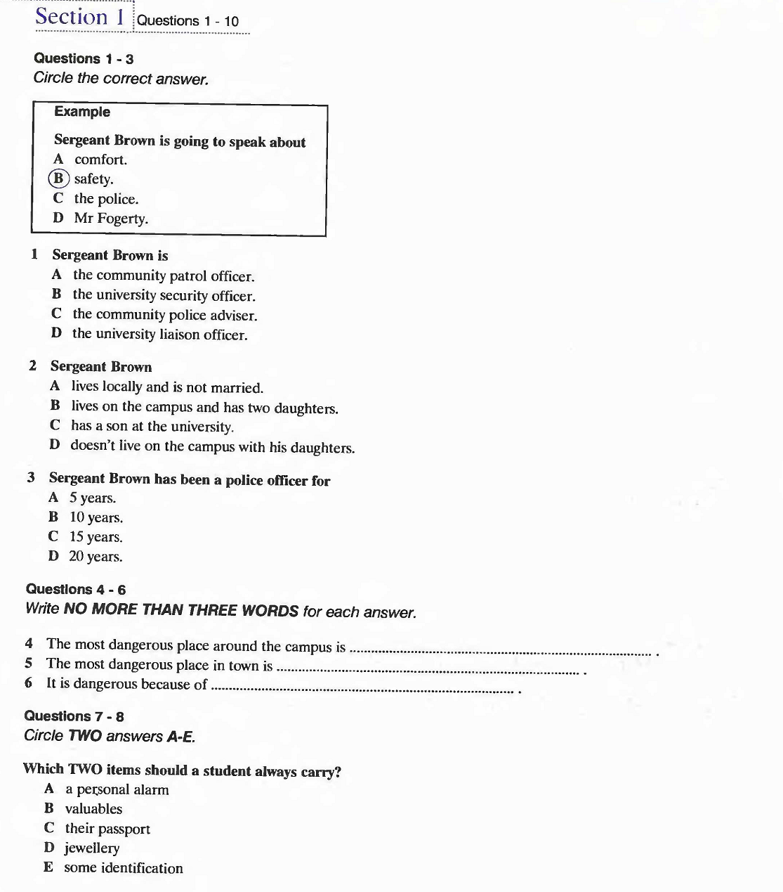

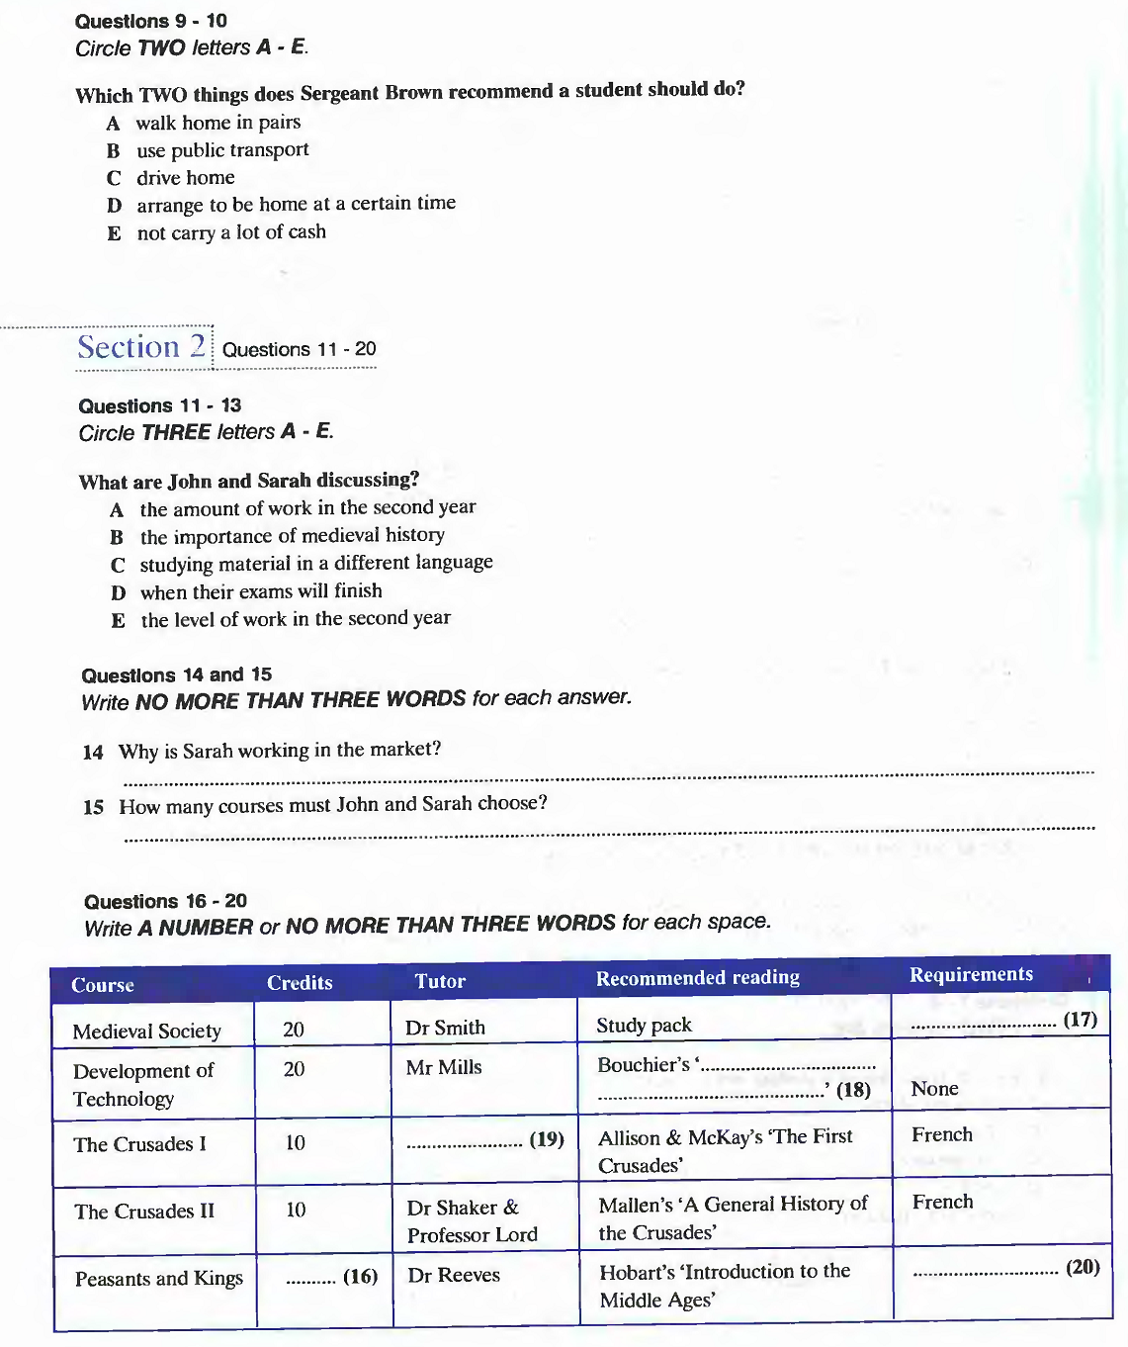 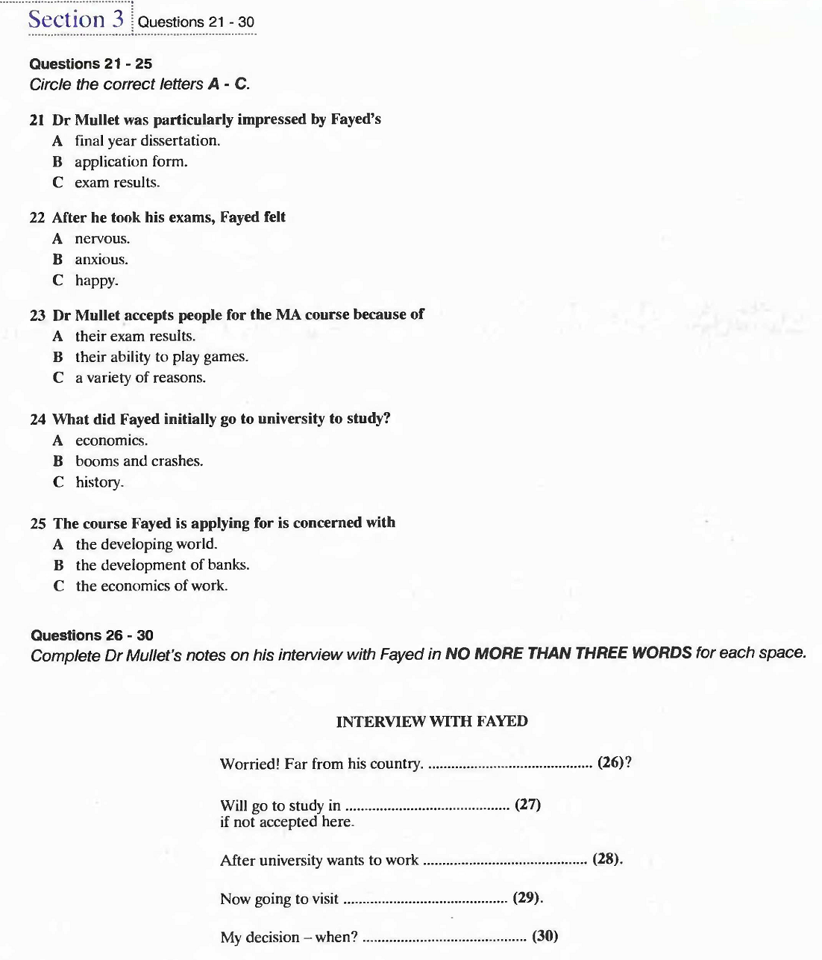 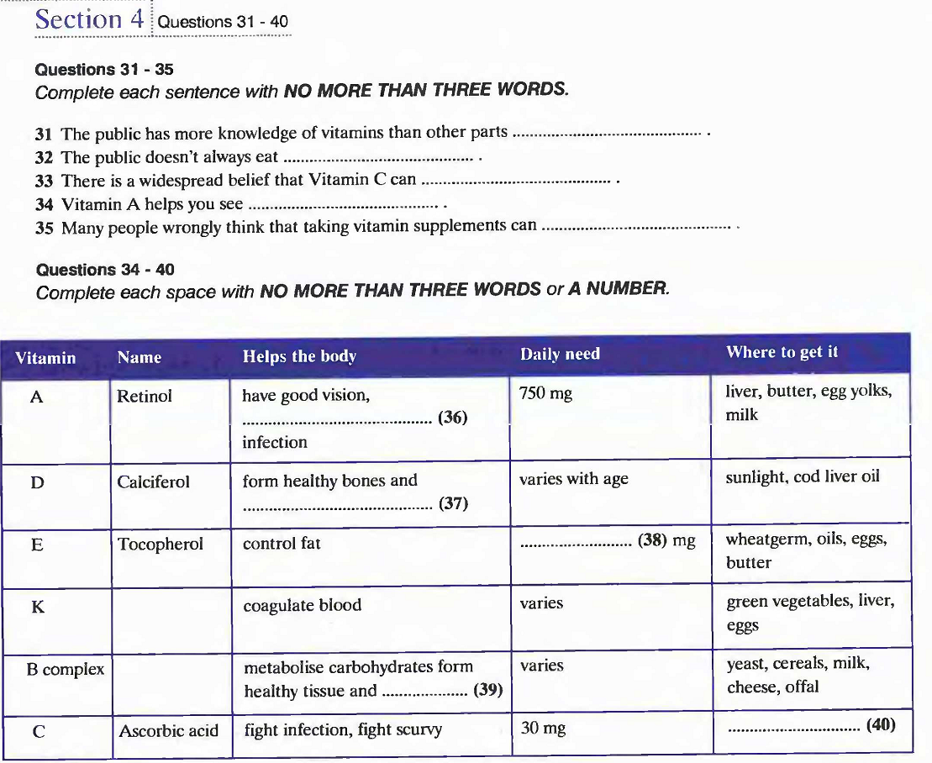

**TASK II: GAP-FILLING**

**Section 1**

**You will hear a policeman giving a talk to some students.**

[man] ... and so I’d like to hand you over now to Sergeant Brown. Thank you.

[2nd man]

Thank you, Mr Fogarty. Er, yes, as you know my name is Sergeant Jeff Brown, and as Mr Fogarty has : indicated, I’ll be speaking to you briefly today about security, about how to make your time at this university safer and more comfortable.

I am officially the university **[...........liaison.....................]**officer, which means I have a specific **[............brief....................]**to act as a go-between for the university and the police, if there are problems, and also to offer an official **[..........present......................]**on or around **[............campus....................]**and give individuals advice if they need it.

Now, my job is very important to me. I take security and reducing the **[..........threat......................]**of crime on this campus very **[........seriously........................]**, because although I don’t actually live on the campus, both my daughters **[...........attend.....................]**this university, and my son is still here. So I am a local **[.............policemen..................]**in every respect. 1 have been the university liaison officer for the last five years but I have been in the police force for 15 in all.

Now, on to some **[..........advice......................]**. The first thing I want to stress is that this university is a **[.............comparatively...................]**safe place to live. We have had no **[.........serious crime.......................]**here in the five years Fve been here. In fact, crime of any sort is very rare on the campus. We have good security here and although there are a lot of staff and students, the **[........security........................]**, including myself, make an effort to get to know your faces!

However, as students it is of course wise for you to take **[........precaution........................]**to protect yourselves against crime when you are off the campus. As I said, the campus itself is really very safe, but there is a large park right behind it, MacGowen Fields, and although this is a beautiful place to sit or walk during the day, at night you must be careful. One or two students have reported **[..........present......................]**incidents at night while walking in the park, although it must be said that no major **[.............incident...................]**have been reported.

Now, there are no areas in town which I advise students to avoid as a **[..............general rule..................]**, but the town centre is more **[........hazardous........................]**than other areas, especially in the evenings on Friday and Saturday. On these days there is often fighting after people have had too much to drink in the pubs and clubs in the area. There have also been a number of robberies and **[................................]**.

Well, that was my advice to you. Most of it is **[................................]**but remember crime always happens when you least expect it. But there are ways to protect yourself. First of all. the university **[................................]**all students with personal alarms. If you are **[................................]**, you can use this to put off your attacker. Secondly, don’t take anything with you that cannot easily be replaced like a **[................................]**or things of **[................................]**value. Leave **[................................]**and other valuables in your room when you go out. Always make sure you take something which will **[................................]**, you, perhaps your student card or your **[................................]**. Thirdly, when you are out late at night, come home in twos. It’s much safer if you’re w ith a friend than on your own. And obviously, don’t have very much money on you. Finally, if you do know you’ll be late back and can’t use public **[................................]**, tell someone else when you **[................................]**to be home and if there’s a problem, they can raise the alarm. So, that’s about all from me and I wish you a pleasant and safe stay here. Thank you.

**Section 2**

**You will hear two students, Sarah and John discussing their choices of courses to study.**

Sarah: Hi, John.

John: Hello, Sarah. What are you doing in here?

Haven't all your exams finished?

Sarah: Well, yes, they have, but I’ve got to make my **[................................]**for next year. I still haven’t chosen what courses I’m going to do.

John: That’s why I’m here. Why don’t we have a look through the **[................................]**together?

Sarah: That’s a good idea. I’m not sure about some of these courses on **[................................]**history.

John: No. In fact, I’m not sure about the whole second year. I was talking to Peter Lily the other day - you know, he’s just **[................................]**the second year - and he was saying that the work load is higher in the second year because you have to read all these medieval documents in Latin. I mean, the first year’s been pretty hard but next year will be **[................................]**. There are more **[................................]**in the second year - it goes up to six a year for each course, doesn't it?

Sarah: Yes. But we’ve got the experience of the first year to build on, so it must get easier. And there isn’t so much secondary **[................................]**in the second year. There aren’t so many books about the medieval **[................................]**.

John: Don't you believe it! 1 think this year’s going to be hard work !

Sarah: Well, perhaps I’d better give up my job then.

John: You’re working as well?

Sarah: Yeah, I’ve been working in the same place for over a year now. Only **[................................]**, you know. Just Saturday mornings in the market. I mean, it doesn’t pay much, but it’s interesting and it gives me a bit of **[................................]**for my text books. Anyway, what about these courses? How many do we have to take? I remember Professor Bolt saying something about four courses in the second year, is that right? Or do we have to do a certain number of **[................................]**?

John: Both. We have to select four courses, but for some courses there are two parts. They count as one course. It’s **[................................]**, because everyone has to do Europe **[................................]**and Chronicles of the **[................................]**. Anyway, when you’ve chosen your four courses, they should add up to **[................................]**. Have you got the course brochure there?

Sarah: Yes. Look ... under ... second year history ...

There it is.

John: Right. Yes, look. Most of these courses are 20 credits each, except for the two short courses about the Crusades. They’re 10 each. Now, Medieval Society ... Hmm. What do you think?

Sarah: Well, actually, I think it looks really good. Dr Smith is OK, and you don’t have to buy any books except a study pack. The best thing is, there are no special **[................................]**- no Latin or medieval English!

John: The next one is Development of Technology with Mr Mills. Ail ... this is a good one. Peter **[................................]**it. It’s all about the way printing **[................................]**, and early science. In fact, I think I could get a copy of Bouchier’s ‘History of Science’ from him. That means I wouldn’t have to buy it.

Sarah: That does look interesting. And that doesn’t have any special **[................................]**either. What’s next...? Ah, here they are. 10 credits each, the **[................................]**. You need French to do them. I suppose a lot of the documents are in **[................................]**.

John: That's strange, look. There are different teachers for each part. I expect that’s why it’s **[................................]**. Dr Clare does the first part, but it’s Dr Shaker and Professor Lord for the second one.

Sarah: So that only leaves **[................................]**and Kings, with Dr Reeves.... Oh, look, you have to know French for this one.

John: Well, I must say I don’t fancy any course that asks you to have Latin, but I think my French is good enough to read **[................................]**.

Sarah: Yes, mine too. Well, what shall we choose ...?

**Section 3**

**You will hear an interview between Dr Mullet, a university lecturer and a student, Fayed.**

Dr Mullet: So, Fayed, you found my office quite easily.

Fayed: Yes, thank you.

Dr Mullet: Thank you for coming such a long way for the **[................................]**. I believe you are from the Middle East. Now, Fayed, I really wanted to speak to you during this interview about two things - your exam **[................................]**and your final-year **[................................]**. Your thesis, your dissertation, that was something quite special. Your personal tutor **[................................]**sent me a copy, and I must say that for a third year **[................................]**it's a veiy polished piece of work.

Fayed: Thank you.

Dr Mullet: Yes, it's very **[................................]**. Now, the thing is, your tutor tells me that you weren’t all that happy with your exams ...

Fayed: Well... The results aren't out yet, as you know. The first four were fine, but in the last three I lost my **[................................]**a bit and didn’t do so well. I know I didn’t do as well as I could. I was **[................................]**when I'd handed in my exams.

Dr Mullet: Right. Well, exams are a bit of a game anyway. We can’t all do well on the day. But here exam results are not everything, as you know - I set great store by other **[................................]**in deciding whether we offer you a place on the Master’s course. Perhaps you could tell me a little about how you became interested in **[................................]**.

Fayed: Yes, of course. Well, I've always been interested in social and economic history, so from a very young age I read about the booms and **[................................]**of the 19th and 20th centuries. I originally **[................................]**to study history at university, but when 1 got there I realised I had the chance to study economics at a high level, so I changed. My mother used to be an economist at the World Bank, so I had her to help me and **[................................]**me. Although she didn’t help . me write my final-year paper!

Dr Mullet: No, quite. Now, you're applying for the Master’s course in the Economics of the Developing World, **[................................]**by myself and Dr Branigan. Why this **[................................]**course?

Fayed: Well, I’ve read some of your work on the development of rural banks and I thought this was a good place to be. I mean, this is my first choice.

Dr Mullet: And you’re not **[................................]**about feeling homesick? You are still young, and Australia is a very long way from your home. I mean, your English is fine, there are no problems with language or **[................................]**, but the **[................................]**from your family may make it hard for you at first.

Fayed: I’ve thought about that. But it’s a problem wherever I go. If I don't get in here, I’ll probably take a place at a university in England. That’s just as far from home!

Dr Mullet: I see, 1 see. And what are your long-term **[................................]**. Fayed? What do you want to do ultimately with your **[................................]**and your life?

Fayed: I want to work in my country. You know there are some problems there, and I want to try to right some of them in the economic **[................................]**.

Dr Mullet: I see. And this is your last interview, I believe. That gives you four weeks before the next term starts. What will you do during your holidays?

Fayed: Oh, I'm going to relax. I was going to work on my English, but in fact I've got a couple of friends in I **[................................]**, so I think I'll go and stay with them instead as I’ve never been to **[................................]**.

H: I see. Well, Fayed, as you know I can't give you a **[................................]**right away. However, I can tell you that you’ve made quite an **[................................]**with your application, and I think you should not worry too much about the place. My decision will be made tomorrow after I’ve seen the last **[................................]**, and I’ll let you know within the next two weeks.

Fayed: Thank you very much.

Dr Mullet: Well, thank you for attending the interview.

**Section 4**

**You will hear a lecturer give a talk on nutrition.**

Now, the topic of today’s talk is **[................................]**- specifically, vitamins and **[................................]**. I’ll be dealing first with some of the most common **[................................]**about them. Then I’m going to talk about what **[................................]**there are, where they come from, and the **[................................]**we need. We’ll have some time at the end of the talk for any questions you may have.

OK. Well, vitamins are known to the general public - in fact, the public knows more about them than it does about certain other key **[................................]**of nutrition. One reason for this is that vitamins have been in the public eye for quite a while - at least since the middle of the **[................................]**, when their importance first became widely **[................................]**. This awareness does mean that the public knows how important vitamins are - even if it doesn’t mean that we all eat a healthy diet all the time. However, a problem does arise that is **[................................]**with this, which is the number of old **[................................]**about vitamins. Usually these fallacies are not dangerous, but they do lead to an **[................................]**high intake of vitamin supplements. For example, it is widely held that high doses of vitamin C will cure colds and flu. I’d like to hit this one on the head - there is no **[................................]**that any vitamin can cure anything! No, I’m afraid you’ll just have to let time sort out your cold. And of course, the body can’t store vitamin C, so those tablets you take are just an **[................................]**waste of time.

Another common belief with no evidence is the idea that vitamin A helps you see in the dark. Actually, there is some truth in this one, because vitamin A is necessary for good **[................................]**. But in the dark, in real darkness, nobody can see. And of course, taking too much vitamin A can actually be bad for you. But perhaps the most **[................................]**idea, heavily promoted by certain companies, is that vitamins will make you **[................................]**. Now, while a healthy diet is **[................................]**if you are to make the most of your intelligence, there is no evidence whatsoever that vitamin **[................................]**can make the slightest bit of difference. (Pause for 3 seconds).

So what can vitamins do? Or, perhaps more **[................................]**, why do we need them? Well, the answer is that we need them for all sorts of reasons.

Vitamin A, for example, also called **[................................]**, is essential for good eyesight, especially at night, and to help us fight off **[................................]**and illness. We get it from liver, butter, **[................................]**and milk.

Vitamin D, as is well known, is used to build strong teeth and **[................................]**, but it also helps us **[................................]**calcium. Vitamin D is mainly formed in the skin through the action of **[................................]**. How much you need depends on different factors such as age and health.

Vitamin E, **[................................]**, is less well-known, but is necessary in maintaining a healthy **[................................]**of fats in the body. We need 10-12 mg every day, and although some people take **[................................]**, you can normally get what you need from a balanced diet.

The B complex includes vitamins BI, **[................................]**, B2, riboflavine, B6, pyridoxine and B12, **[................................]**. It performs many functions, including allowing our bodies to metabolise carbohydrates, forming healthy tissue, and perhaps most importantly, forming red blood cells to prevent **[................................]**. We need varying amounts of the B complex, and while most of us can get enough from a **[................................]**diet, vegetarians may find themselves deficient in B12, which is only found in any **[................................]**quantity in meat, especially liver.

Finally, vitamin C is the one everyone knows. **[................................]**acid, as it’s also known, helps fight infection, which perhaps accounts for the myth about preventing colds. It also helps protect against **[................................]**. We need 30 mg a day, and can only really get this amount from eating plenty of citrus fruit and fresh vegetables. Now, in a moment I'll be moving on to talk about how we can plan a diet which will **[................................]**all our vitamin needs. But before that. I'd like to look at some of the recent **[................................]**in our knowledge of the ways vitamin **[................................]**can affect us ...

(fade)